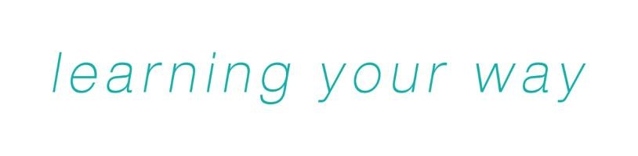

Personal Learning and Thinking Skills
Recording Documents

Recording Documents for PLTS Outcomes

There must be a clear audit trail that all the PLTS Outcomes have been met. Although centres may devise their own cross-referencing documents, Gateway Qualifications has provided the following documents which can be used to record the achievement of all the PLTS Outcomes.

For each of the PLTS outcomes, learners should identify where these have been evidenced. Assessors should comment on the achievement of the outcomes and employers should be encouraged to comment on how effectively these have been demonstrated in the workplace.

REMEMBER that evidence for the PLTS outcomes can be drawn from any part of the apprenticeship framework.

Independent Enquirers

Outcome | How was the outcome evidenced? | Where is the evidence? | Date Completed
IE1 I have identified questions to answer and problems to resolve

IE2 I have planned and carried out research, appreciating the consequences of decisions

IE3 I have explored issues, events or problems from different perspectives

IE4 I have analysed and evaluated information, judging its relevance and value

IE5 I have considered the influence of circumstances, beliefs and feelings on decisions and events
IE6 I have supported conclusions, using reasoned arguments and evidence

Assessor Comments:

Employer Comments:

Please sign when all outcomes have been achieved

Learner Signature: __________________________________ Date: ______________

Assessor Signature: __________________________________ Date: ______________

Creative Thinkers

Outcome | How was the outcome evidenced? | Where is the evidence? | Date Completed
CT1 I have generated ideas and explored possibilities

CT2 I have asked questions to extend my thinking

CT3 I have connected my own and others’ ideas and experiences in inventive ways

CT4 I have questioned my own and others’ assumptions

CT5 I have tried out alternatives or new solutions and followed ideas through

CT6 I have adapted my ideas as circumstances change.

Assessor Comments:

Employer Comments:

Please sign when all outcomes have been achieved

Learner Signature: __________________________________ Date: ______________

Assessor Signature: __________________________________ Date: ______________

Reflective Learners

Outcome | How was the outcome evidenced? | Where is the evidence? | Date Completed
RL1 I have assessed myself and others, identifying opportunities and achievements
RL2 I have set goals with success criteria for my development and work

RL3 I have reviewed progress, acting on the outcomes

RL4 I have invited feedback and dealt positively with praise, setbacks and criticism

RL5 I have evaluated experiences and learning to inform future progress

RL6 I have communicated my learning in relevant ways for different audiences.

Assessor Comments:

Employer Comments:

Please sign when all outcomes have been achieved

Learner Signature: __________________________________ Date: ______________

Assessor Signature: __________________________________ Date: ______________

Team Workers

Outcome | How was the outcome evidenced? | Where is the evidence? | Date Completed
TW1 I have collaborated with others to work towards common goals

TW2 I have reached agreements, managing discussions to achieve results

TW3 I have adapted my behaviour to suit different roles and situations, including leadership roles
TW4 I have shown fairness and consideration to others

TW5 I have taken responsibility, showing confidence in myself and my contribution
TW6 I have provided constructive support and feedback to others

Assessor Comments:

Employer Comments:

Please sign when all outcomes have been achieved

Learner Signature: __________________________________ Date: ______________

Assessor Signature: __________________________________ Date: ______________

Self-Managers

Outcome | How was the outcome evidenced? | Where is the evidence? | Date Completed
SM1 I have sought out challenges or new responsibilities and show flexibility when priorities change
SM2 I have worked towards goals, showing initiative, commitment and perseverance

SM3 I have organised my time and resources, prioritising actions

SM4 I have anticipated, taken and managed risks

SM5 I have dealt with competing pressures, including personal and work-related demands
SM6 I have responded positively to change, seeking advice and support when needed

SM7 I have managed my emotions, and built and maintained relationships

Assessor Comments:

Employer Comments:

Please sign when all outcomes have been achieved

Learner Signature: __________________________________ Date: ______________

Assessor Signature: __________________________________ Date: ______________

Effective Participators

Outcome | How was the outcome evidenced? | Where is the evidence? | Date Completed
EP1 I have discussed issues of concern, seeking resolution where needed

EP2 I have presented a persuasive case for action

EP3 I have proposed practical ways forward, breaking these down into manageable steps

EP4 I have identified improvements that would benefit others as well as myself
EP5 I have tried to influence others, negotiating and balancing diverse views to reach workable solutions
EP6 I have acted as an advocate for views and beliefs that may differ from my own.

Assessor Comments:

Employer Comments:

Please sign when all outcomes have been achieved

Learner Signature: __________________________________ Date: ______________

Assessor Signature: __________________________________ Date: ______________

Personal Learning and Thinking Skills (PLTS) achievement declaration form

Apprenticeship | Tick

Apprentice’s Full Name
Employer Name
Provider Name

PLTS | Date Achieved
Independent Enquirer
Creative Thinker
Reflective Learner
Team Worker
Self-Manager
Effective Participator

I confirm that all of the PLTS have been achieved as part of the above apprenticeship programme
 | Name | Signature | Date
Apprentice
Provider

