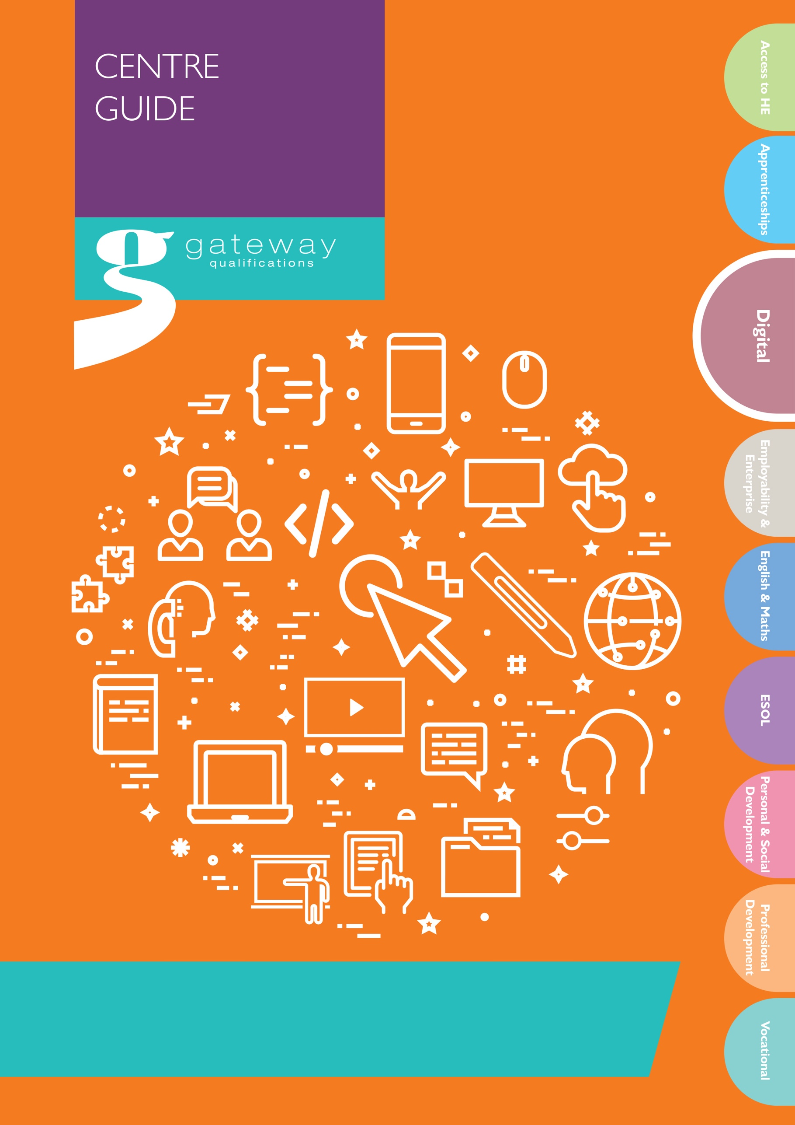
Standardisation Material
Essential Digital Skills E3 Samples
Entry 3 Task 6 Sample A

For Sale!
Nearly new wooden table and 4 chairs.
The table is in good condition with a few marks on the top. The chairs are in excellent condition and have never been used.
Moving to a smaller house and no longer have room for a dining set.
This is an absolute bargain! Price: £75 (Or nearest offer)
Delivery is not available; buyer must collect.
From a smoke and pet free home.
If you would like to come and see the table and chairs or make an offer, please call on 06247 987123 or email moveit@bmail.com
No time wasters please.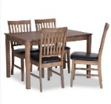

Entry 3 Task 6 Sample B

For Sale!

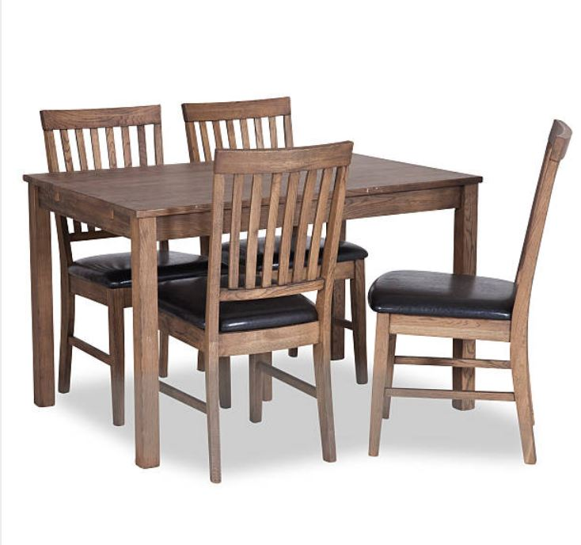

Nearly new wooden table and 4 chairs. The table is in good condition with a few marks on the top. The chairs are in excellent condition and have never been used. Moving to a smaller house and no longer have room for a dining set.
This is an absolute bargain!
- Price: £65 (Or nearest offer)
- Delivery is not available; buyer must collect.
- From a smoke and pet free home.
If you would like to come and see the table and chairs or make an offer, please call on 06247 987123 or email moveit@bmail.com

No time wasters please.

Entry 3 Task 6 Sample C

For Sale!
Nearly new wooden table and 4 chairs. The table is in good condition with a few marks on the top. The chairs are in excellent condition and have never been used. Moving to a smaller house and no longer have room for a dining set. This is an absolute bargain!
Price: £65 (Or nearest offer)

Entry 3 Task 6 Sample D

For Sale!
Nearly new wooden table and 4 chairs. The table is in good condition with a few marks on the top. The chairs are in excellent condition and have never been used. Moving to a smaller house and no longer have room for a dining set. This is an absolute bargain!
Price: £75 (Or nearest offer)
Delivery is not available; buyer must collect.
From a smoke and pet free home.
If you would like to come and see the table and chairs or make an offer, please call on 06247 987123 or email moveit@bmail.com
No time wasters please.

