Standardisation Material
Essential Digital Skills L1 Samples

Level 1 Task 4 Sample A

LK Services- IT Apprentice Vacancy

Do you like working with computers and solving problems? Are you looking to start a career in IT? An apprenticeship could be for you! Apprenticeships provide on-the-job training, while you earn. They are open to all ages, whether you have just left school, or you are looking for a career change. LK Services is known for its outstanding customer service and our values are at the heart of everything we do. We have been working in the service industry for nearly ten years and specialise in facilities management. These are some of the qualities we look for when recruiting staff: Reliability- can you keep to deadlines or work shifts at short notice? Team player- Do you work well with colleagues and customers? Flexibility- Can you help out when needed? A cool head- Do you keep calm under pressure? Availability- Can you work shifts, including evenings and weekends? Whether you are starting out in the industry or have years of experience, we provide ongoing training to all our staff. We also have regular team building days and charity events. We are always looking for enthusiastic team players.

To find out more, or apply, contact Mary@lkservices.net

Level 1 Task 4 Sample B

LK Services- IT Apprentice Vacancy

Do you like working with computers and solving problems? Are you looking to start a career in IT? An apprenticeship could be for you! Apprenticeships provide on-the-job training, while you earn. They are open to all ages, whether you have just left school, or you are looking for a career change.

LK Services is known for its outstanding customer service and our values are at the heart of everything we do. We have been working in the service industry for nearly ten years and specialise in facilities management. These are some of the qualities we look for when recruiting staff: Reliability- can you keep to deadlines or work shifts at short notice?
To find out more, or apply, contact
Mary@ikservices.net
Team player- Do you work well with colleagues and customers? Flexibility- Can you help out when needed? A cool head- Do you keep calm under pressure? Availability - Can you work shifts, including evenings and weekends? Recruitment V1

Level 1 Task 4 Sample C

LK Services - ITS Apprentice Vacancy
Do you like working with computers and solving problems? Are you looking to start a career in IT? An apprenticeship could be for you! Apprenticeships provide on-the-job training, while you earn. They are open to all ages, whether you have just left school, or you are looking for a career change.
LK Services is known for its outstanding customer service and our values are at the heart of everything we do. We have been working in the service industry for nearly ten years and specialise in facilities management.
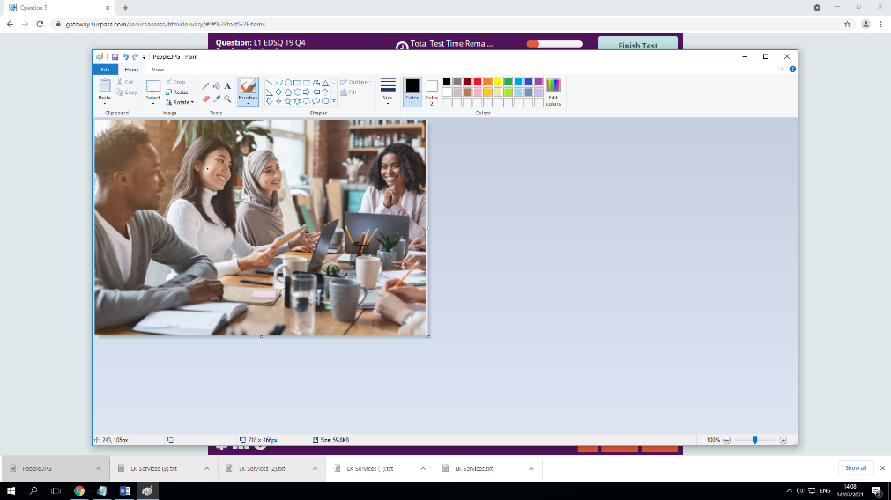
These are some of the qualities we look for when recruiting staff: Reliability- can you keep to deadlines or work shifts at short notice? Team player- Do you work well with colleagues and customers? Flexibility- Can you help out when needed? A cool head- Do you keep calm under pressure? Availability- Can you work shifts, including evenings and weekends? Whether you are starting out in the industry or have years of experience, we provide ongoing training to all our staff. We also have regular team building days and charity events. We are always looking for enthusiastic team players.

To find out more, or, apply contact Mary@Ikservices.net

Level 1 Task 4 Sample D

LK Services - IT Apprentice Vacancy
Do you like working with computers and solving problems? Are you looking to start a career in IT? An apprenticeship could be for you! Apprenticeships provide on-the-job training, while you earn. They are open to all ages, whether you have just left school, or you are looking for a career change.
About us
LK Services is known for its outstanding customer service and our values are at the heart of everything we do. We have been working in the service industry for nearly ten years and specialise in facilities management.

Work for us
These are some of the qualities we look for when recruiting staff: Reliability- can you keep to deadlines or work shifts at short notice? Team player- Do you work well with colleagues and customers? Flexibility- Can you help out when needed? A cool head- Do you keep calm under pressure? Availability- Can you work shifts, including evenings and weekends? Whether you are starting out in the industry or have years of experience, we provide ongoing training to all our staff. We also have regular team building days and charity events. We are always looking for enthusiastic team players.
y, contact Mary@lkservices.net

